**REPORT OF THE DIGITAL ELECTRONICS LAB PROJECT**

**ON**

**Design & Implementation of Digital Stopwatch**



SUBJECT: Digital Electronics Lab (ESC-312)

SUBMITTED TO: Dr. Rajinder Tiwari

GROUP MEMBERS: Ayush Thakur, Rakshit Gupta, Udhayveer

ROLL NUMBERS : 2021A1R049, 2021A1R050, 2021A1R051

SEMESTER: 3rd CSE

**Abstract**

The measurement of time has always been an essential aspect of human life, and the ability to accurately track and record time has had a significant impact on the development of society. From the early sundials and hourglasses to modern atomic clocks, humans have continually sought out more precise and reliable methods of measuring time.

One common device used for measuring time is the stopwatch. A stopwatch is a handheld timepiece that is designed to measure the amount of time that has elapsed from a specific starting point. Stopwatches can be mechanical or digital, with digital stopwatches being the more popular choice due to their accuracy and ease of use.

A digital stopwatch is a stopwatch that displays the elapsed time using digits, rather than hands on a dial. Digital stopwatches can be programmed to measure a wide range of time intervals, from fractions of a second to several hours. They are commonly used in sporting events, laboratory experiments, and other situations where the precise measurement of time is important.

The aim of this project was to design and construct a digital stopwatch using basic electronic components. The goal was to create a device that was capable of accurately measuring time intervals and displaying the elapsed time on a display

**What is a stop watch?**

A stopwatch is a handheld timepiece designed to measure the amount of time elapsed from a particular time when it is activated to the time when the piece is deactivated. A large digital version of a stopwatch designed for viewing at a distance, as in a sports stadium, is called a stop clock.

**7 segment Digital stop watch using decoder**

**AIM**: To make a Digital stopwatch circuit that can count from 0 to 99 seconds which can also be used for different applications like photo counter, countdown timer and alarm clock.

**Introduction**:

Stopwatches find use as time keeping devices in many fields, namely sports. Stopwatches may be analog or digital. Digital stopwatches are much more common than the analog version owing to their higher accuracy and ease of use. Here we have tried to realize a digital stopwatch of reasonable accuracy and reliability.

This particular stopwatch can count up to 9 minutes and 59.9 seconds .It is accurate up to one tenth of a second. The circuit is relatively simple and easy to realize .The heart of the circuit is a stable mv followed by counter and decoder stages. The circuit is explained extensively in the following pages.The circuit operates on 5-v dc supply. It uses a seven segment LED display of common anode type show time.

**Components used**

* IC 4033 - 2
* 555 timer IC -1
* Common Cathode 7 Segment Display -2
* 150 Ohm -1
* 100K resistor -1
* 33K resistor -1
* 56K resistor -1
* 10uF capacitor -1
* On/off switch -1
* Push button -1
* Bread board -1
* 9 Volt Battery -1
* Battery Connector -1
* LED -1
* Voltage Regulator 7805 -1
* Connecting wires

1. Breadboard- A breadboard (sometimes called a plug block) is used for building temporary circuits. It is useful to designers because it allows components to be removed and replaced easily. It is useful to the person who wants to build a circuit to demonstrate its action, then to reuse the components in another circuit.
2. LED - LED is a light emitting diode product that assembles into a lamp for the use in lighting fixtures. LEDs are used both for general and special purpose lighting but most LED do not emit light in all directions. Presently multi colored LEDs are available for commercial use.
3. POWER SUPPLY - A 9V DC battery/bench power supply is used to power up the entire circuit.
4. Connecting Wires - They are used to connect the circuit.
5. 555 Timer - The 555 timer IC is an integrated circuit used in a variety of timer, delay, pulse generation, and oscillator applications. Derivatives provide two or four timing circuits in one package
6. 7805 IC - 7805 IC, a member of 78xx series of fixed linear voltage regulators used to maintain such fluctuations, is a popular voltage regulator integrated circuit (IC). The xx in 78xx indicates the output voltage it provides. 7805 IC provides +5 volts regulated power supply with provisions to add a heat sink.
7. 7446 IC - The NTE7446 is a BCD-to-Seven-Segment Decoder/Driver in a 16-Lead plastic DIP type package that features active-low outputs designed for driving common-anode VLEDs or incandescent indicators directly. This device has full ripple-blanking input/output controls and a lamp test input.

**Circuit Diagram**

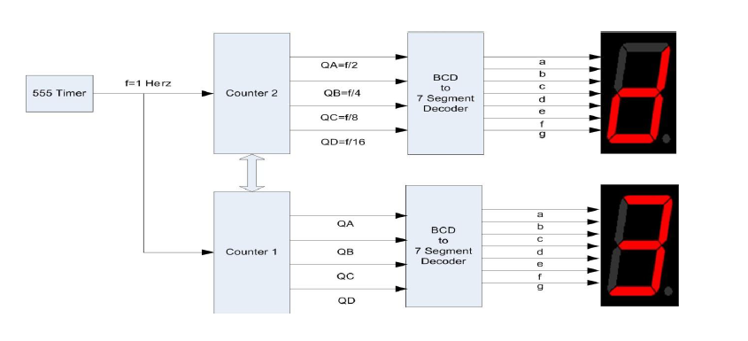

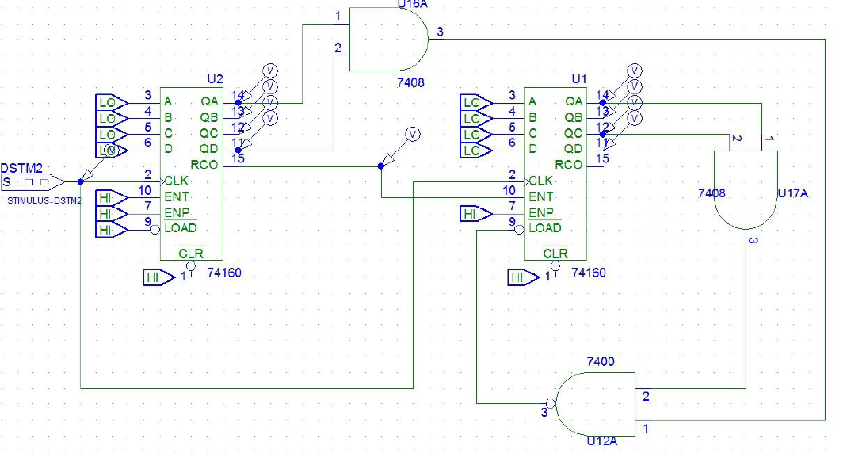

**Application**

Digital stopwatches are frequently used in digital electronics as a way to measure time intervals and as a reference for other timing-related functions. Some specific ways in which digital stopwatches are used in digital electronics include:

1. Timing delays: Digital stopwatches can be used to measure the duration of delays in digital circuits. For example, a digital stopwatch can be used to measure the time it takes for a signal to propagate through a circuit or for a device to complete a specific task.
2. Synchronization: Digital stopwatches can be used to synchronize the operation of different devices in a digital system. For example, a digital stopwatch can be used to ensure that data is transferred between devices at regular intervals.
3. Triggering events: Digital stopwatches can be used to trigger events in digital circuits. For example, a digital stopwatch can be used to turn on a device after a certain amount of time has elapsed or to initiate a sequence of events at regular intervals.
4. Measuring performance: Digital stopwatches can be used to measure the performance of digital systems. For example, a digital stopwatch can be used to measure the time it takes for a computer to complete a specific task or for a network to transfer data.